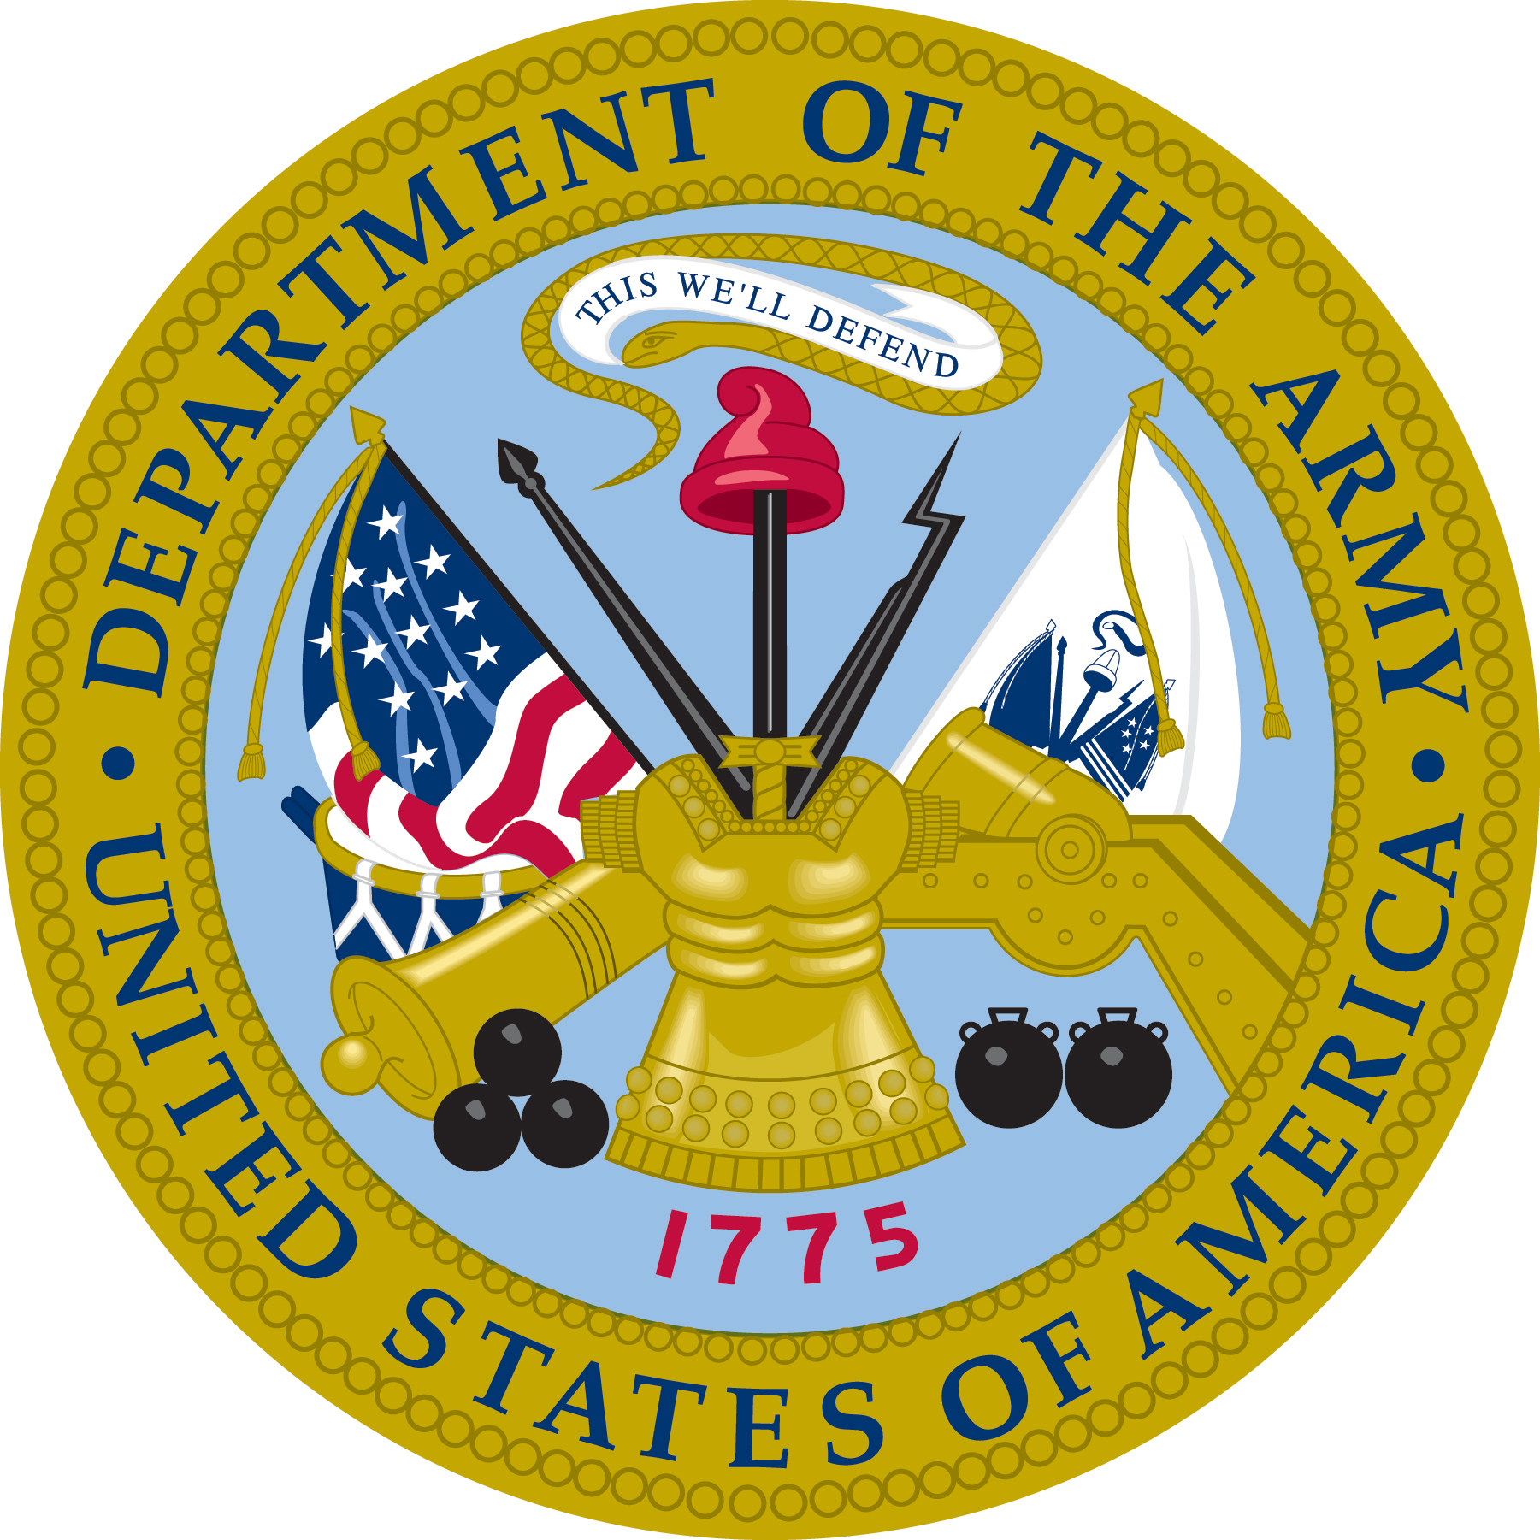 | DEPARTMENT OF THE ARMY  1st Cavalry Division  1st Armored Brigade Combat Team  Killen, Texas  Fort Hood | 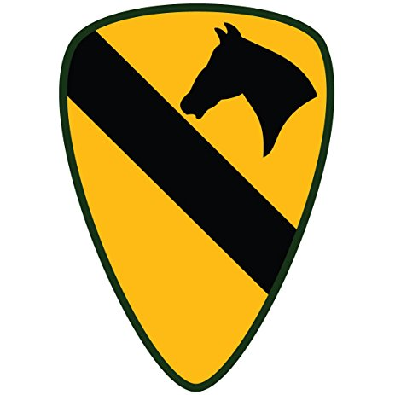
20-JAN-2018
Order Number: 2018-DOA-1CAV-1ABCT-01
1st Cavalry Division,
1st Armored Brigade Combat Team
w/ Supporting Divisional Assets
The U.S. Army units shown and its members are ordered to deployment to Mogadishu, Somalia for the period shown and will proceed from the home station to the duty station shown. On completion of deployment, will return to home station and revert to training / garrison status.
Authority: Department of Defense, US AFRICOM, Combined Joint Task Force – Horn of Africa (CJTF-HOA)
Duty station: [Classified] Kismayo, Somalia
Period: 01-FEB-2018 to 31-MAY-2018
Personnel main body: 1st Cavalry Division
1st Armored Brigade Combat Team
- Headquarters and Headquarters Battalion
- 1-7th Cavalry (Combined Arms Battalion [Enhanced/Long-Range])
- 2-5th Cavalry (Combined Arms Battalion)
- 2-8th Cavalry (Combined Arms Battalion)
- 2-12th Cavalry (Armored Reconnaissance Squadron)
- 115th Brigade Support Battalion
- 2-227th Aviation (General Support)
- 7-17th Cavalry (Attack Reconnaissance)
Advance party: HHBn and HHC 1-7th Cavalry
Government convoy personnel: 3rd Battalion, Somali National Army
Rear detachment: 91st Brigade Support Battalion, 1st Armored Brigade Combat Team, 1st Cavalry Division
Personnel authorized individual travel: None.
Personnel excused from deployment: All personnel on TDA with TRADOC.
Personnel authorized change in deployment dates: All personnel on TDA with TRADOC or LOA.
Movement data: Moving from Fort Hood via 3rd Air Support Operations Group, to Ramstein Air Base, Germany, then moved via 449th Air Expeditionary Group to Camp Lemonnier, Djibouti–Ambouli International Airport. From Djibouti will airlift to [Classified], Kismayo, Somalia. From [Classified], Kismayo, Somalia will move via organic assets to southern Mogadishu, Somalia.
Format: 550 MG Paul T. Calvert
Commanding
Distribution: All Personnel
(Not for Public Distribution)

